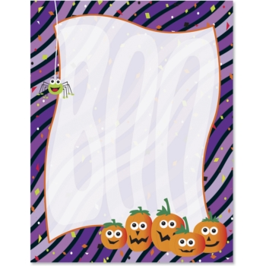
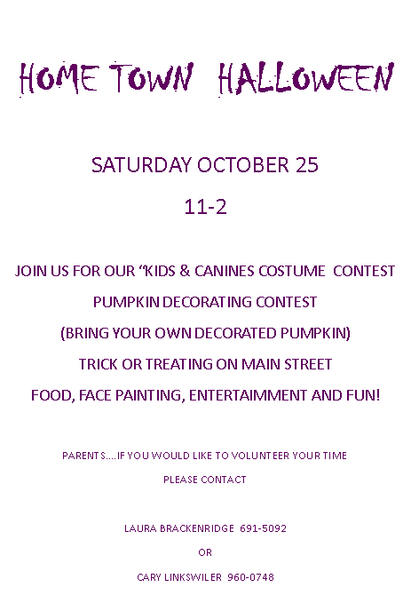

HOME TOWN HALLOWEEN

SATURDAY OCTOBER 25
11-2

JOIN US FOR OUR “KIDS & CANINES COSTUME CONTEST
PUMPKIN DECORATING CONTEST
(BRING YOUR OWN DECORATED PUMPKIN)
TRICK OR TREATING ON MAIN STREET
FOOD, FACE PAINTING, ENTERTAIMMENT AND FUN!

PARENTS….IF YOU WOULD LIKE TO VOLUNTEER YOUR TIME
PLEASE CONTACT

LAURA BRACKENRIDGE 691-5092
OR
CARY LINKSWILER 960-0748

HOME TOWN HALLOWEEN

SATURDAY OCTOBER 25
11-2

JOIN US FOR OUR “KIDS & CANINES COSTUME CONTEST
PUMPKIN DECORATING CONTEST
(BRING YOUR OWN DECORATED PUMPKIN)
TRICK OR TREATING ON MAIN STREET
FOOD, FACE PAINTING, ENTERTAIMMENT AND FUN!

PARENTS….IF YOU WOULD LIKE TO VOLUNTEER YOUR TIME
PLEASE CONTACT

LAURA BRACKENRIDGE 691-5092
OR
CARY LINKSWILER 960-0748

